
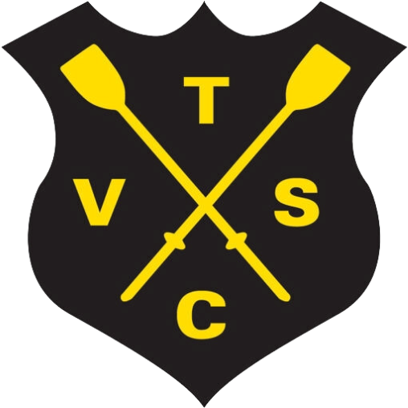
TVSC Events Calendar
2026
Date:
Event:
Saturday 24th January
Sausage Fest
Sunday 1
st
February
Treasure Hunt
Friday 13th February
Film Night
Friday 21st February
Lent Film Night & Pancakes
Saturday 28
th
February
Bingo
Saturday 21
st
March
Art Attack
Tuesday 24th March
AFM
Saturday 11th April
Mexican-Themed Games Night
Saturday 16
th
May
Eurovision Party
June (TBC)
President’s Party
Sunday 27th September
Macmillan Coffee Morning
Sunday 18th October
L2R Welcome
Saturday 24th October
Crew's Supper
October (TBC)
AGM
Saturday, 14th November
Through the lens: Club Photo Awards
Saturday 12th December (TBC)
Punting Supper
Sunday 20th December
Christmas Draw
Thursday 31st December
New Year's Eve Gala

